Sip N’ Bite

A PROJECT REPORT
SUBMITTED BY
Chauhan Deep ET25MTCA005
Patel Yash ET25MTCA047
Viras Prathamesh ET25MTCA066

UNDER THE GUIDANCE OF
Dr. Krishna Vaidya
In Fulfilment of Subject
Mobile App Development With Web Integration [MTCA26322]
Of
Master of Computer Applications
At

Sarvajanik College of Engineering and Technology, Surat.
Sarvajanik University
December, 2026

 | Sarvajanik Education Society  Sarvajanik College of Engineering & Technology, Surat.  Department of Computer Applications Academic Year:2026-27

Date:

CERTIFICATE

This is to certify that the project entitled “Sip N’ Bite” has been submitted by Chauhan Deep ET25MTCA005 towards the fulfillment for the subject Mobile App Development With Web Integration in 3rd Semester of MCA of Sarvajanik University, Surat during the academic year 2026-2027.

Prof. Dr. Krishna Vaidya Dr. Prashant Keswani
(Guide’s Signature) (Head- Department of computer application)

Examiner’s Signature
1.
2.

Sarvajanik Education Society
Sarvajanik College of Engineering & Technology, Surat.
Department of Computer Applications Academic Year:2026-27

Date:

CERTIFICATE

This is to certify that the project entitled “Sip N’ Bite” has been submitted by Patel Yash ET25MTCA047 towards the fulfillment for the subject Mobile App Development With Web Integration in 3rd Semester of MCA of Sarvajanik University, Surat during the academic year 2026-2027.

Prof. Dr. Krishna Vaidya Dr. Prashant Keswani
(Guide’s Signature) (Head- Department of computer application)

Examiner’s Signature
1.
2.

Sarvajanik Education Society
Sarvajanik College of Engineering & Technology, Surat.
Department of Computer Applications Academic Year:2026-27

Date:

CERTIFICATE

This is to certify that the project entitled “Sip N’ Bite” has been submitted by Viras Prathamesh ET25MTCA066 towards the fulfillment for the subject Mobile App Development With Web Integration in 3rd Semester of MCA of Sarvajanik University, Surat during the academic year 2026-2027.

Prof. Dr. Krishna Vaidya Dr. Prashant Keswani
(Guide’s Signature) (Head- Department of computer application)

Examiner’s Signature
1.
2.

Acknowledgement

I would like to express my sincere gratitude to my respected Ma’am , Dr. Vaidya Krishna, for his valuable guidance, continuous support, and encouragement throughout the completion of this project on Sip N’ Bite. His insights and suggestions played a significant role in shaping this work.

I am also thankful to Sarvajanik College of Engineering and Technology for providing me with the opportunity and the necessary resources to successfully carry out this project.

I would like to extend my appreciation to my friends and classmates for their cooperation, helpful discussions, and support during the development of this project.

Finally, I express my heartfelt thanks to my family for their constant motivation, encouragement, and understanding, which helped me complete this project successfully.

This project has been a valuable learning experience, and I am grateful to everyone who directly or indirectly contributed to its completion.

Chauhan Deep
Patel Yash
Viras Prathamesh

INDEX

Sr. No | Content | Page No.
1. | Introduction  - Proposed system and its Objectives  - Core Components  - Minimum and Maximum Software/Hardware requirements  - Advantages and Limitations of the Proposed System
2. | Requirement Determination & Analysis  - Requirement Determination  - Targeted Users
3. | System Design  - Use Case Diagram  - Class Diagram  - Interaction Diagram  - Activity Diagram  - Deployment Diagram  - Data Dictionary
4. | Agile Documentation  - Agile Project Charter  - Agile Roadmap / Schedule / Agile Project Plan  - Agile User Story ( Minimum 3 Tasks)  - Agile Release Plan  - Agile Sprint Backlog  - Agile Test Plan  - Earned-value and burn charts
5. | Screenshots
6. | Conclusion
7. | Bibliography

Introduction

Sip N’ Bite is a modern café management system developed using Laravel and React Native. The system is designed to digitalize and streamline café operations by integrating online table reservations, food ordering, and secure payment processing into a single platform.
In today’s fast-paced environment, customers prefer quick and convenient services. This system addresses that need by allowing users to book tables in advance, explore the food menu, order food, and complete payments online through a use r-friendly mobile application. These features help reduce waiting time and enhance the overall customer experience. Additionally, it assists administrators in efficiently managing reservations, food orders, menu items, monitoring transactions, and maintaining organized café operations.
The project emphasizes usability, efficiency, and reliability, making it suitable for real-world café environments.

  - Proposed System and its Objectives

The proposed Sip N' Bite platform bridges the gap between customer convenience and back-office restaurant operations. It features a dual-interface architecture: a responsive Web Admin Portal for the restaurant owner/manager, and a modern Android Mobile Application engineered for diners.

Objectives:

- To develop a web-based platform and Android application for easy table reservation and ordering food.
- To implement secure and efficient online payment integration.
- To minimize manual errors and operational delays.
- To enhance customer convenience through digital services.
- To provide administrators with centralized control and monitoring.
- To maintain accurate and structured data for future analysis.

1.2 Core Components

The system is structured into the following core components:

- Customer:

Enables users to register, log in, check table availability, make reservations, order food, and perform online payments through a simple and user-friendly interface.

- Admin:

Provides functionalities for managing bookings, orders, customer information, payment records, and system updates through a centralized dashboard.

- Reservation Management System:

Handles real-time table allocation, scheduling, booking confirmations, and availability tracking for efficient reservation management.

- Payment Processing Module:

Ensures secure, reliable, and efficient handling of online transactions with payment confirmation and transaction status tracking.

- Database Management System (MySQL):

Stores and manages all application data, including user profiles, booking details, order information, and transaction history.

1.3 Minimum and Maximum Software/Hardware Requirements

- Software Requirements
  - Minimum Configuration:

    - Operating System: Android 8.0 or later
    - React Native Framework
    - Expo SDK
    - JavaScript / TypeScript
    - Android Studio / Expo Go
    - Internet Connection

  - Recommended Configuration:.

    - Operating System: Android 12 or later
    - Latest Stable React Native Version
    - Latest Stable Expo SDK
    - Node.js (LTS Version)
    - Android Studio with Android SDK
    - EAS Build for Application Packaging
    - Internet Connection

- Hardware Requirements
  - Minimum Configuration:

    - RAM: 4 GB
    - Processor: Quad-core processor or equivalent
    - Storage: 500 MB free space
    - Device: Android smartphone
    - Internet: Wi-Fi or mobile data connection

  - Recommended Configuration:

    - RAM: 6 GB or higher
    - Processor: Octa-core processor or above
    - Storage: 2 GB or more free space
    - Device: Android smartphone with an updated OS
    - Internet: Stable Wi-Fi or 4G/5G connection
1.4 Advantages and Limitations of the Proposed System

- Advantages

- Provides convenient and time-saving online booking
- Enables secure digital payment transactions
- Reduces dependency on manual processes
- Improves operational efficiency and service quality
- Offers real-time table availability and booking management
- Enhances customer satisfaction through a smooth user experience

- Limitations

- Requires stable internet connectivity for operation
- Initial setup and maintenance efforts are required
- Security measures must be properly implemented to protect transactions
- Limited accessibility for users unfamiliar with digital systems

2. Requirement Determination & Analysis

2.1 Requirement Determination

Requirement determination is a crucial phase in system development, where the needs of users and system functionalities are clearly identified and analyzed. For the Sip N’ Bite system, requirements are gathered based on the operational challenges faced in traditional café management and the growing demand for digital services.

- Functional Requirements:

- The system should allow users to register and log in securely
- Users must be able to view available tables and book them in advance
- The system should support online payment processing
- Admin should be able to manage bookings, customers, and transactions
- The system should maintain records of all reservations and payments
- Users should receive confirmation of booking and payment

- Non-Functional Requirements:

- Usability: The interface should be simple and user-friendly
- Performance: The system should respond quickly to user requests
- Security: User data and transactions must be protected
- Reliability: The system should function consistently without failure
- Scalability: The system should handle increasing users efficiently

2.2 Targeted Users

- TARGETED USERS
The Sip N’ Bite system is designed to serve different categories of users, each with specific roles and requirements:
1. Customers
• Individuals who want to book tables online
• Users who prefer cashless and quick payment options
• Customers seeking convenience and time-saving services
2. Café Administrator (Admin)
• Responsible for managing bookings and table availability
• Monitors customer details and transaction records
• Ensures smooth operation of the system
• Handles updates and maintenance of the platform
3. Delivery Partner
• Responsible for picking up and delivering customer orders
• Can view available delivery requests and accept orders
• Updates order status after successful delivery
• Maintains delivery history and tracks completed orders
• Ensures timely and efficient delivery service

3.System Design

  - Use Case Diagram

- Admin

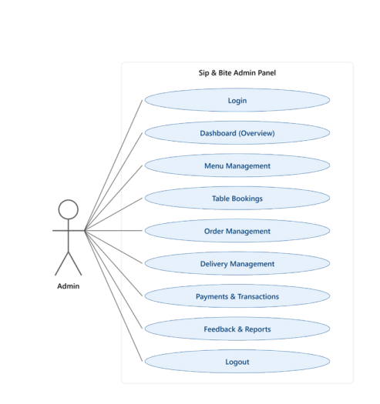

- Customer
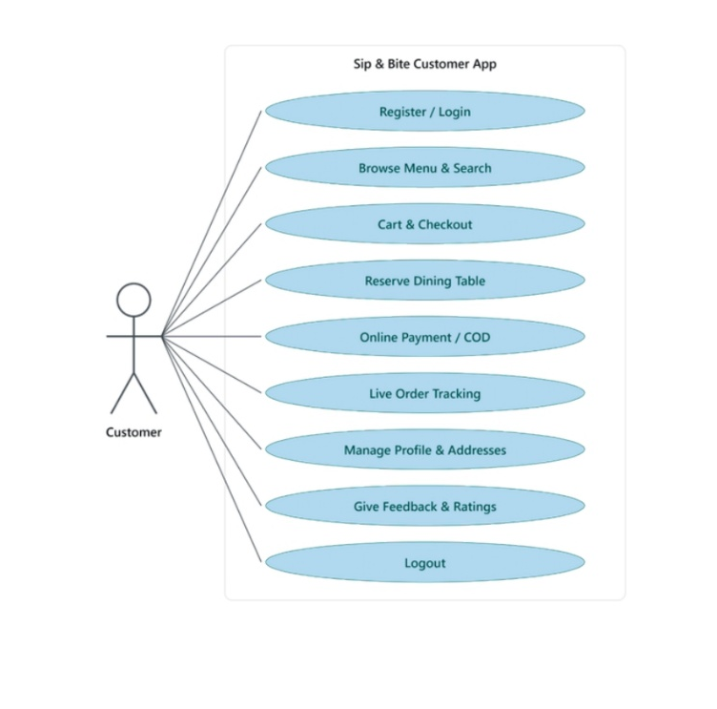

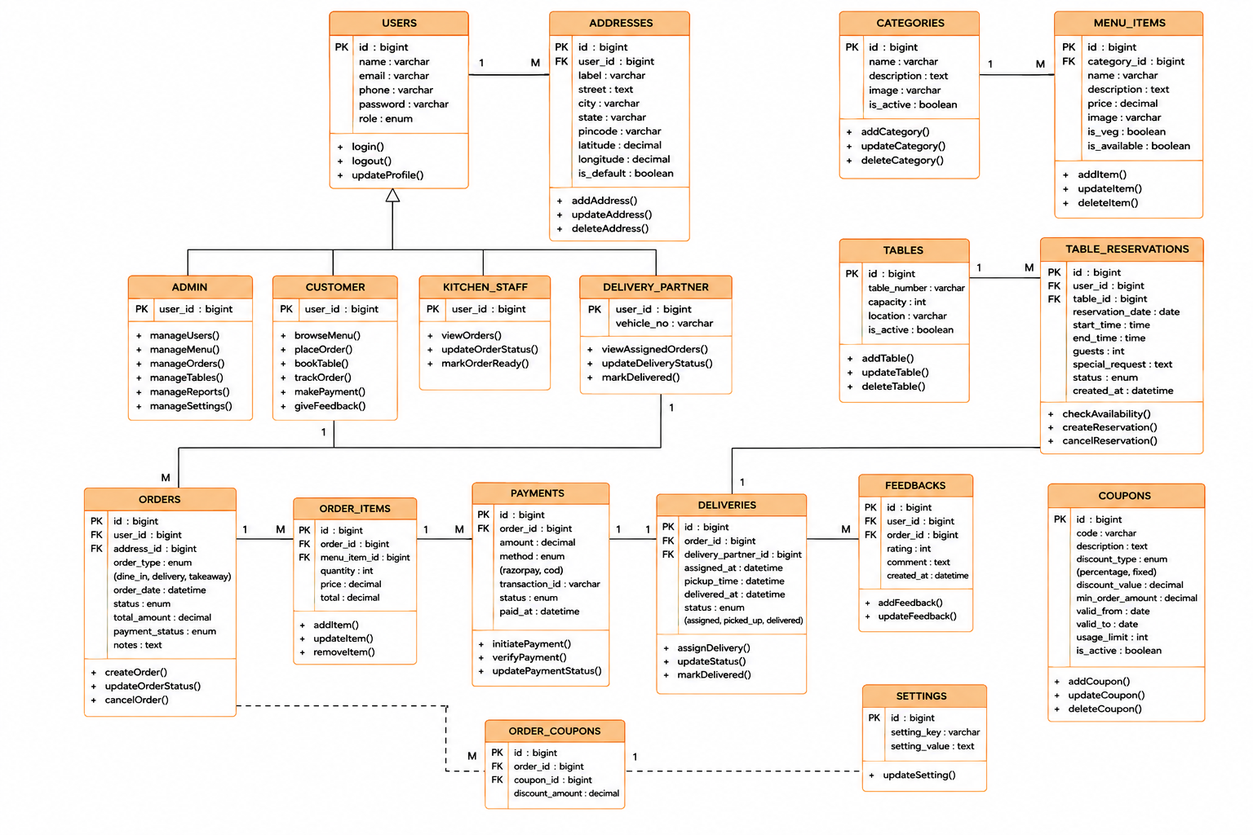
  - Class Diagram

  - Interaction Diagram

- Customer Side:-

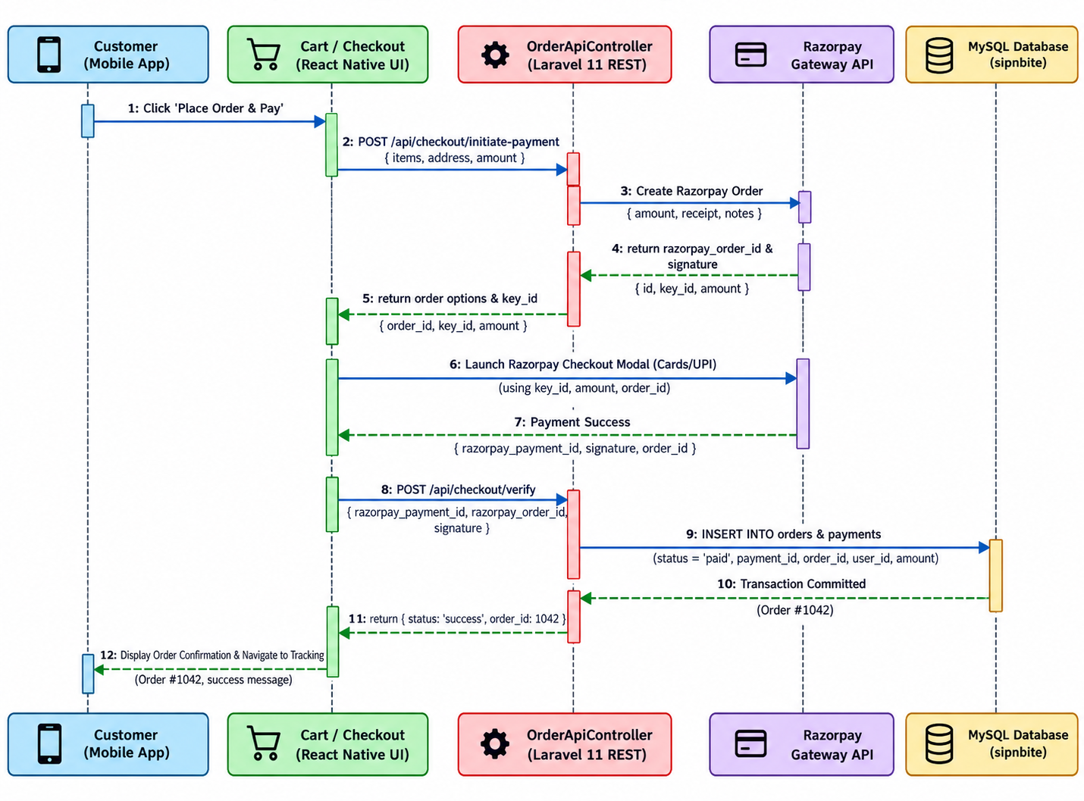

- Admin Side:-

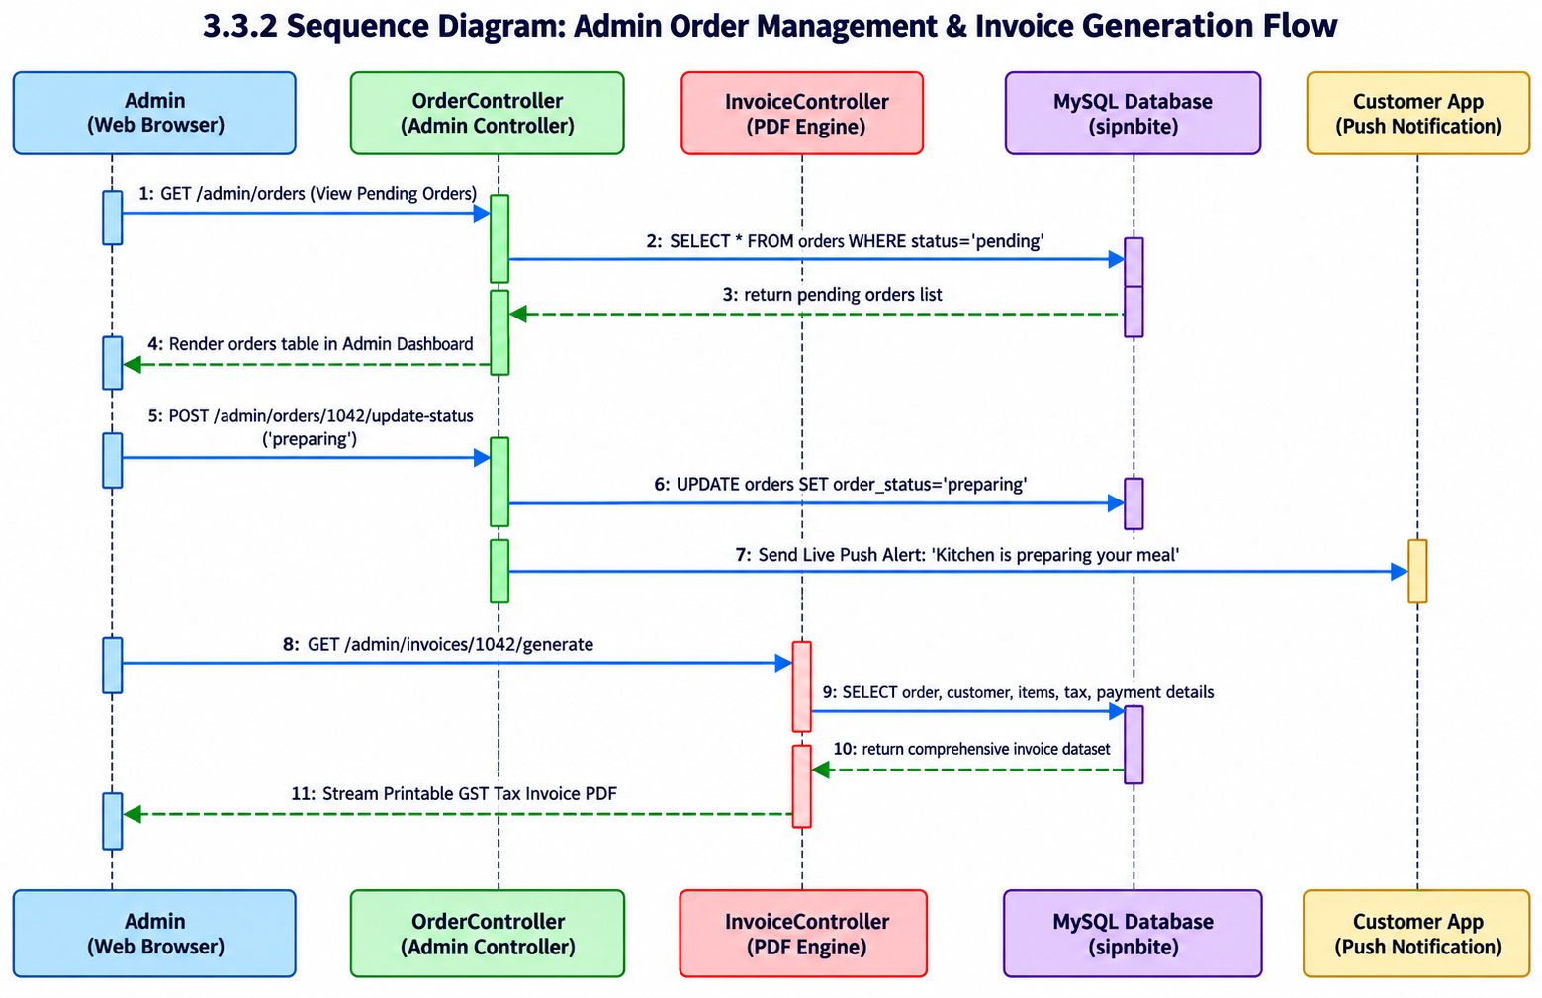
3.4 Activity Diagrams

- Admin Side:-
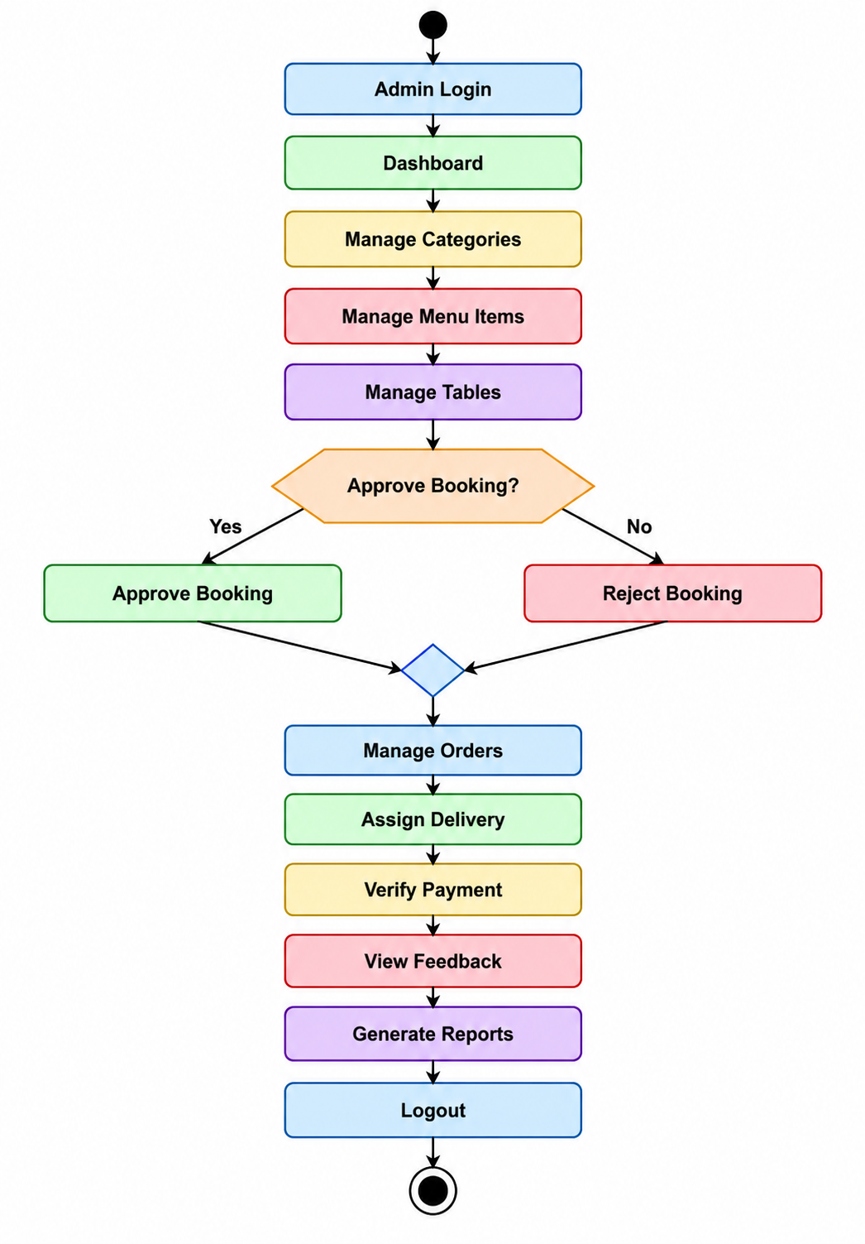

- Customer Side:-

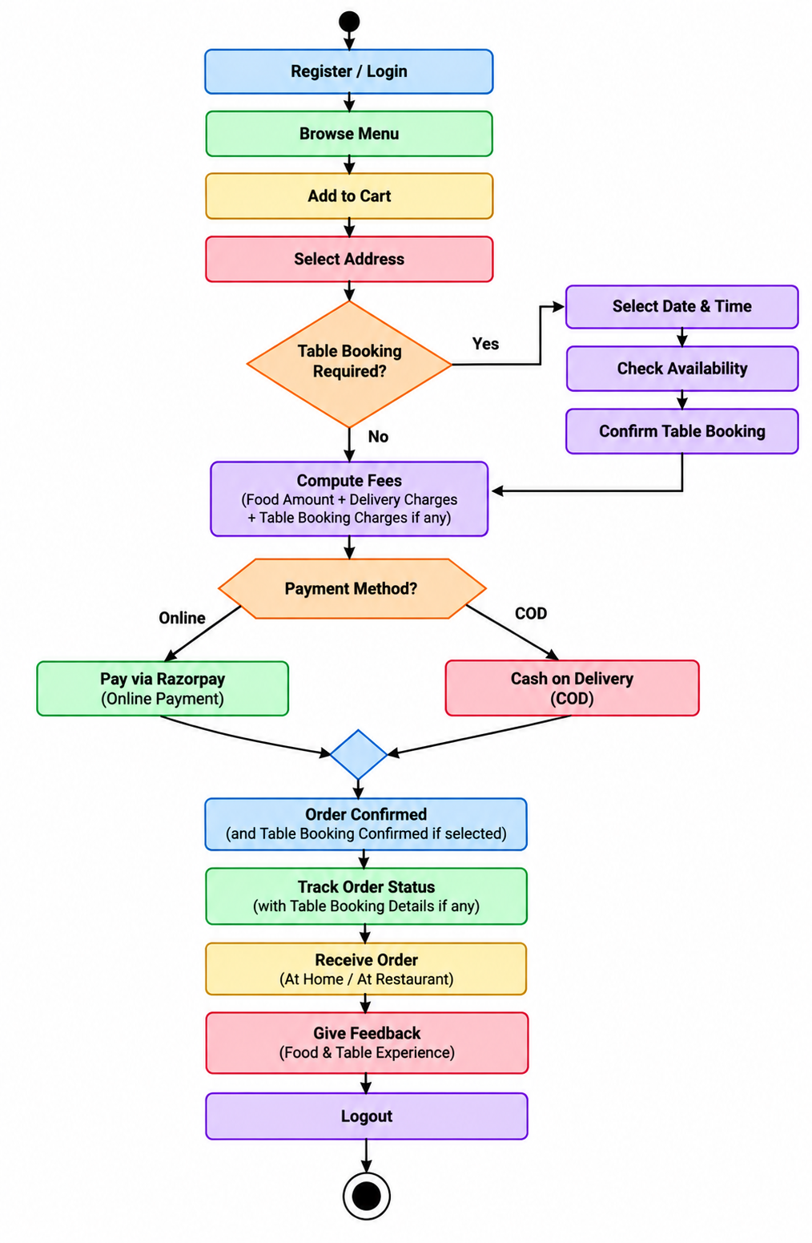

3.5 Deployment Diagram

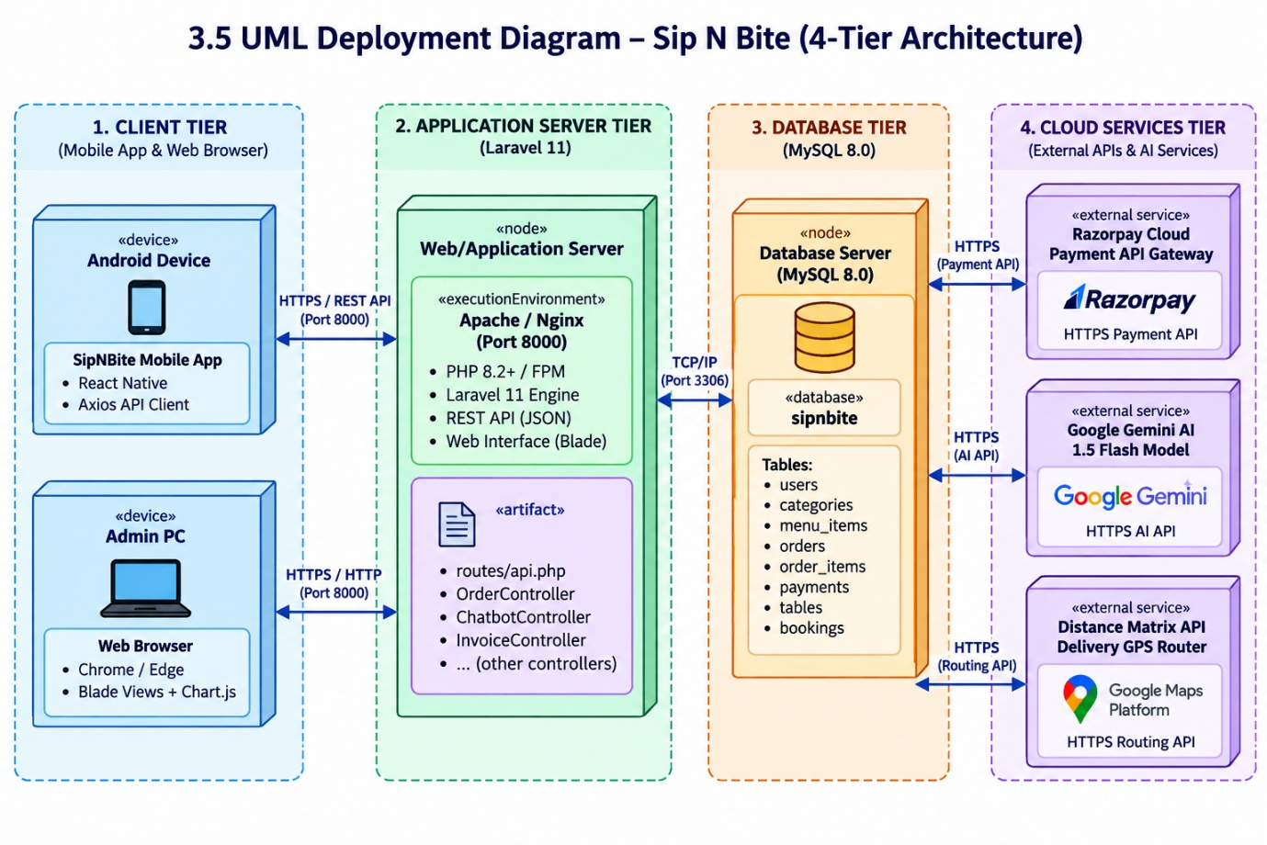

  - Data Dictionary
- Customer
It Stores Registration And Authentication Details Of The Customers.

Field Name | Data Type | Constraints / Keys | Description & Purpose
Id | BIGINT UNSIGNED | PK, Auto Increment | Unique user identifier
name | VARCHAR(191) | NOT NULL | Full name of the user
email | VARCHAR(191) | NOT NULL, UNIQUE | User email address for authentication
phone | VARCHAR(191) | NULLABLE | Contact phone number
password | VARCHAR(191) | NOT NULL | Bcrypt hashed security password
role | ENUM('admin','customer','delivery') | DEFAULT 'customer' | Access control role
status | VARCHAR(50) | DEFAULT 'active' | Account status flag
created_at / updated_at | TIMESTAMP | NULLABLE | Audit timestamp records

- Categories:

It Stores menu’s categories with proper manner.
Field Name | Data Type | Constraints / Keys | Description & Purpose
id | BIGINT UNSIGNED | PK, Auto Increment | Unique category identifier
name | VARCHAR(191) | NOT NULL | Category display title (e.g. Pizza, Burgers)
slug | VARCHAR(191) | NOT NULL, UNIQUE | URL-friendly slug
image | VARCHAR(191) | NULLABLE | Relative image asset path
description | TEXT | NULLABLE | Summary description of category
status | TINYINT(1) | DEFAULT 1 | Active availability toggle

- Menu_items:

It used to store food details with name, price and image.

Field Name | Data Type | Constraints / Keys | Description & Purpose
id | BIGINT UNSIGNED | PK, Auto Increment | Unique food item identifier
category_id | BIGINT UNSIGNED | FK -> categories(id) | Associated food category
name | VARCHAR(191) | NOT NULL | Name of the dish
description | TEXT | NULLABLE | Ingredients and culinary summary
price | DECIMAL(10,2) | NOT NULL | Unit price in INR (₹)
image | VARCHAR(191) | NULLABLE | Image filename stored in public assets
is_available | TINYINT(1) | DEFAULT 1 | Kitchen stock availability status
is_veg | TINYINT(1) | DEFAULT 1 | Vegetarian (1) or Non-Vegetarian (0) badge
rating | DECIMAL(3,2) | DEFAULT 4.5 | Aggregated customer rating score

- Orders:

It used to store order recorders which placed by the users.

Field Name | Data Type | Constraints / Keys | Description & Purpose
id | BIGINT UNSIGNED | PK, Auto Increment | Unique order internal ID
order_number | VARCHAR(191) | NOT NULL, UNIQUE | Formatted business order ID (e.g. ORD-1042)
user_id | BIGINT UNSIGNED | FK -> users(id) | Customer placing the order
delivery_person_id | BIGINT UNSIGNED | FK -> delivery_persons(id), NULL | Assigned delivery rider
address_id | BIGINT UNSIGNED | FK -> addresses(id), NULL | Selected delivery location
subtotal | DECIMAL(10,2) | NOT NULL | Gross item cost before taxes
tax | DECIMAL(10,2) | NOT NULL | 5% CGST/SGST tax total
delivery_fee | DECIMAL(10,2) | DEFAULT 40.00 | Distance-based delivery surcharge
total_amount | DECIMAL(10,2) | NOT NULL | Net payable invoice sum
payment_method | VARCHAR(50) | NOT NULL | 'cod' or 'razorpay'
payment_status | VARCHAR(50) | DEFAULT 'pending' | 'pending', 'paid', or 'failed'
order_status | VARCHAR(50) | DEFAULT 'pending' | 'pending', 'preparing', 'out_for_delivery', 'delivered'

- Order_items:

It is used to store order items/food details which Is used place in order.

Field Name | Data Type | Constraints / Keys | Description & Purpose
id | BIGINT UNSIGNED | PK, Auto Increment | Unique line item identifier
order_id | BIGINT UNSIGNED | FK -> orders(id), ON DELETE CASCADE | Parent order reference
menu_item_id | BIGINT UNSIGNED | FK -> menu_items(id) | Referenced dish
item_name | VARCHAR(191) | NOT NULL | Snapshot of item name at time of order
price | DECIMAL(10,2) | NOT NULL | Snapshot unit price
quantity | INT | NOT NULL | Number of portions ordered
subtotal | DECIMAL(10,2) | NOT NULL | Line subtotal (price * quantity)

- Table:

It is use to store table details.

Field Name | Data Type | Constraints / Keys | Description & Purpose
id | BIGINT UNSIGNED | PK, Auto Increment | Dining table identifier
table_number | VARCHAR(50) | NOT NULL, UNIQUE | Physical table label (e.g. Table #1)
capacity | INT | NOT NULL | Maximum seating capacity (e.g. 2, 4, 6, 8)
location_type | VARCHAR(100) | DEFAULT 'Indoor' | Indoor, Outdoor Patio, or Rooftop
status | VARCHAR(50) | DEFAULT 'available' | 'available', 'reserved', 'maintenance'

- Table_booking:

It used to stored booking of the table.
Field Name | Data Type | Constraints / Keys | Description & Purpose
id | BIGINT UNSIGNED | PK, Auto Increment | Dining table identifier
table_number | VARCHAR(50) | NOT NULL, UNIQUE | Physical table label (e.g. Table #1)
capacity | INT | NOT NULL | Maximum seating capacity (e.g. 2, 4, 6, 8)
location_type | VARCHAR(100) | DEFAULT 'Indoor' | Indoor, Outdoor Patio, or Rooftop
status | VARCHAR(50) | DEFAULT 'available' | 'available', 'reserved', 'maintenance'
4. Agile Documentation

  - Agile Project Charter

Field | Details
Project Name | Sip N’ Bite
Project By | Chauhan Deep  Patel Yash  Viras Prathamesh
Project Type | Android & Web Based Application
Technology Used | React Native, PHP, Laravel, MySQL, Expo
Start Date | 14/07/2026
End Date | *Empty*

  - Agile Roadmap / Schedule

1st Quarter | 2nd Quarter
 | Design and structure the system and draw various diagrams such as:  • Use Case Diagram (Admin and Customer)  • Class Diagram  • Activity Diagram  • Interaction Diagram  • Deployment Diagram  Design database (menu, orders, users, payments) and prepare data dictionary for the system.
  Understand the project idea of Sip N Bite – Food Ordering, Table Booking & Delivery System. Gather requirements for Admin And Customer modules. Finalize project scope, identify target users, and define core features like menu browsing, food ordering, online payment etc.. Implementation Of AI in both sides(android and Web.)
3rd Quarter | 4th Quarter
 | Implement additional features for better usability such as order tracking, notifications, and improved UI. Optimize system performance, fix bugs, and ensure proper analysis and smooth working of the system.
  Develop the system using Laravel framework and React Native. Implement front-end and back-end modules including:
  • Customer (registration, login, order food, payment)
  • Admin (manage menu, orders, users)
  • AI chatbot
  Perform validation testing on all pages and prepare documentation alongside development.

  - Agile Project Plan

Task Name | Responsible | Start Date | End Date | Days | Status
Sprint 1 | Chauhan Deep, Patel Yash , Viras Prathamesh. | 14/07/2026 | 21/07/2026 | 7 | Complete
Project Definition | All | 14/07/2026 | 15/07/2026 | 1 | Complete
RequirementGathering | All | 15/07/2026 | 17/07/2026 | 2 | Complete
Project Scope | All | 17/07/2026 | 17/07/2026 | 1 | Complete
Core Components | All | 17/07/2026 | 19/07/2026 | 2 | Complete
Target Users | All | 20/07/2026 | 21/07/2026 | 1 | Complete
Sprint 2 | Chauhan Deep, Patel Yash , Viras Prathamesh. | 30/07/2026 | 06/08/2026 | 7 | Complete
Use Case Diagram | Deep , Prathamesh | 30/07/2026 | 01/08/2026 | 2 | Complete
Class Diagram | Yash | 02/08/2026 | 04/08/2026 | 2 | Complete
Activity Diagram | Deep , Yash | 04/08/2026 | 06/08/2026 | 2 | Complete
Database Design | Deep , Prathamesh | 06/08/2026 | 06/08/2026 | 1 | Complete
Sprint 3 | Chauhan Deep, Patel Yash , Viras Prathamesh. | 11/08/2026 | 27/08/2026 | 18 | Complete
Frontend Development | Deep, Prathamesh | 12/08/2026 | 19/08/2026 | 8 | Complete
Backend Development | Yash | 13/08/2026 | 17/08/2026 | 5 | Complete
Integration | All | 23/08/2026 | 27/08/2026 | 5 | Complete
Sprint 4 | Chauhan Deep, Patel Yash , Viras Prathamesh. | 08/09/2026 | 01/10/2026 | 24 | Complete
Testing | Deep, Prathamesh | 09/09/2026 | 12/09/2026 | 3 | Complete
Bug Fixing | Prathamesh , Yash | 13/09/2026 | 20/09/2026 | 8 | Complete
UI Improvement | Deep | 29/09/2026 | 01/10/2026 | 3 | Complete
Final Sprint | Chauhan Deep , Patel Yash , Viras Prathamesh | / /2026 | / /2026 |  | Complete
Documentation | Deep, Yash | / /2026 | / /2026 |  | Complete
Presentation Preparation | All | / /2026 | / /2026 |  | Complete
Final Submission | All | / /2026 | / /2026 |  | Complete

  - Agile User Story

Story Point | Story
1. Admin Management | As an Admin, I can manage menu items, categories, users, and orders so that the system remains organized and updated.
2. Order Management | As an Admin, I can view and manage all customer orders and assign them to delivery partners for smooth operation.
3. Customer Registration & Login | As a Customer, I can register and log in using my credentials so that I can access the food ordering system securely.
4. Food Ordering | As a Customer, I can browse menu items, add them to cart, and place orders with online payment for convenience.
5. Order Tracking | As a Customer, I can track my order status in real-time so that I know when my food will be delivered.
6. Delivery Management | As a Delivery Partner, I can view assigned orders and update delivery status so that orders are delivered efficiently.

  - Agile Release Plan
Sprint | Task Name | Responsible | Start Date | End Date | Days | Status | Release
1 | Project Definition | All | 14/07/2026 | 14/07/2026 | 1 | Released | 14/07/2026
1 | Requirement Gathering | All | 15/07/2026 | 17/07/2026 | 2 | Released | 17/07/2026
1 | Project Scope | All | 17/07/2026 | 17/07/2026 | 1 | Released | 17/07/2026
1 | Core Components | All | 17/07/2026 | 19/07/2026 | 2 | Released | 19/07/2026
1 | Target Users | All | 20/07/2026 | 21/07/2026 | 1 | Released | 21/07/2026
2 | Use Case Diagram | Yash, Prathamesh | 30/07/2026 | 01/08/2026 | 2 | Released | 01/08/2026
2 | Class Diagram | Deep, Prathamesh | 02/08/2026 | 04/08/2026 | 2 | Released | 04/08/2026
2 | Activity Diagram | Deep, Yash | 04/08/2026 | 06/08/2026 | 2 | Released | 06/08/2026
2 | Database Design | All | 06/08/2026 | 06/08/2026 | 1 | Released | 06/08/2026
3 | Frontend Development | Deep, Prathamesh | 12/08/2026 | 19/08/2026 | 8 | Released | 19/08/2026
3 | Backend Development | Yash | 13/08/2026 | 17/08/2026 | 5 | Released | 17/08/2026
3 | Integration | All | 23/08/2026 | 27/08/2026 | 5 | Released | 27/08/2026
4 | Testing | Deep, Prathamesh | 09/09/2026 | 12/09/2026 | 3 | Released | 12/09/2026
4 | Bug Fixing | Deep, Yash | 13/09/2026 | 20/09/2026 | 8 | Released | 20/09/2026
4 | UI Improvement | Prathamesh | 29/09/2026 | 01/10/2026 | 3 | Released | 01/10/2026
Final | Documentation | Deep, Yash | 20/04/2026 | 27/04/2026 | 3 | Released | 27/04/2026
Final | Presentation Preparation | All | / /2026 | / /2026 |  | Released | / /2026
Final | Final Submission | All | / /2026 | //2026 |  | Released | / /2026

  - Agile Sprint Backlog

User Story & ID | Task ID | Task | Assigned To | Status | Original Estimate (Days) | Actual Result (Days)
US1: Admin Module | US1.1 | Login | Deep | Complete | 1 | 1
 | US1.2 | Manage Menu | Yash | Complete | 3 | 3
 | US1.3 | Manage Category | Prathamesh | Complete | 2 | 2
 | US1.4 | Manage Order | Deep | Complete | 3 | 4
 | US1.5 | Generate Invoice | Prathamesh | Complete | 2 | 2
 | US1.6 | Logout | Yash | Complete | 1 | 1
 |  | Total (US1) |  |  | 12 | 13
US2: Customer Module | US2.1 | Registration/Login | Prathamesh | Complete | 2 | 2
 | US2.2 | View Menu | Yash | Complete | 2 | 2
 | US2.3 | Add to Cart | Deep | Complete | 2 | 3
 | US2.4 | Make Payment | Prathamesh | Complete | 3 | 4
 | US2.5 | View Invoice | Deep | Complete | 2 | 2
 | US2.6 | Logout | Yash | Complete | 1 | 1
 |  | Total (US2) |  |  | 12 | 14
US3: Delivery Partner Module | US3.1 | Login | Prathamesh | Complete | 1 | 1
 | US3.2 | View Profile | Deep | Complete | 2 | 2
 | US3.3 | View History | Prathamesh | Complete | 2 | 2
 | US3.4 | View Available Orders | Deep | Complete | 2 | 2
 | US3.5 | View Customer Details | Yash | Complete | 2 | 3
 | US3.6 | Delivered Order | Deep | Complete | 2 | 2
 | US3.7 | View Order History | Yash | Complete | 2 | 2
 | US3.8 | Logout | Yash | Complete | 1 | 1
 |  | Total (US3) |  |  | 14 | 15

  - Agile Test Plan

Test No. | Test Date | Action | Expected Result | Actual Result | Status
1 | 10/05/2026 | Login (Admin/Customer/Delivery) | User can log in with valid credentials | As Expected | Pass
2 | 10/05/2026 | Registration (Customer) | Customer can register successfully | As Expected | Pass
3 | 10/05/2026 | Menu View (Customer) | Customer can view available food items | As Expected | Pass
4 | 10/05/2026 | Add to Cart | Items can be added to cart | As Expected | Pass
5 | 10/05/2026 | Make Payment | Payment processed successfully | As Expected | Pass
6 | 10/05/2026 | View Invoice | Invoice generated after order | As Expected | Pass
7 | 10/05/2026 | Manage Menu (Admin) | Admin can add/edit/delete menu items | As Expected | Pass
8 | 10/05/2026 | Manage Category (Admin) | Admin can manage categories | As Expected | Pass
9 | 10/05/2026 | Manage Orders (Admin) | Admin can view/update order status | As Expected | Pass
10 | 10/05/2026 | Generate Invoice (Admin) | Admin can generate invoice | As Expected | Pass
11 | 10/05/2026 | View Available Orders (Delivery) | Delivery partner can view orders | As Expected | Pass
12 | 10/05/2026 | View Customer Details (Delivery) | Delivery partner can view customer info | As Expected | Pass
13 | 10/05/2026 | Delivered Order (Delivery) | Delivery status updates successfully | As Expected | Pass
14 | 10/05/2026 | View Order History (Delivery) | Delivery partner can view past orders | As Expected | Pass
15 | 10/05/2026 | Logout (All Users) | User logs out successfully | As Expected | Pass

  - Earned-value and burn charts

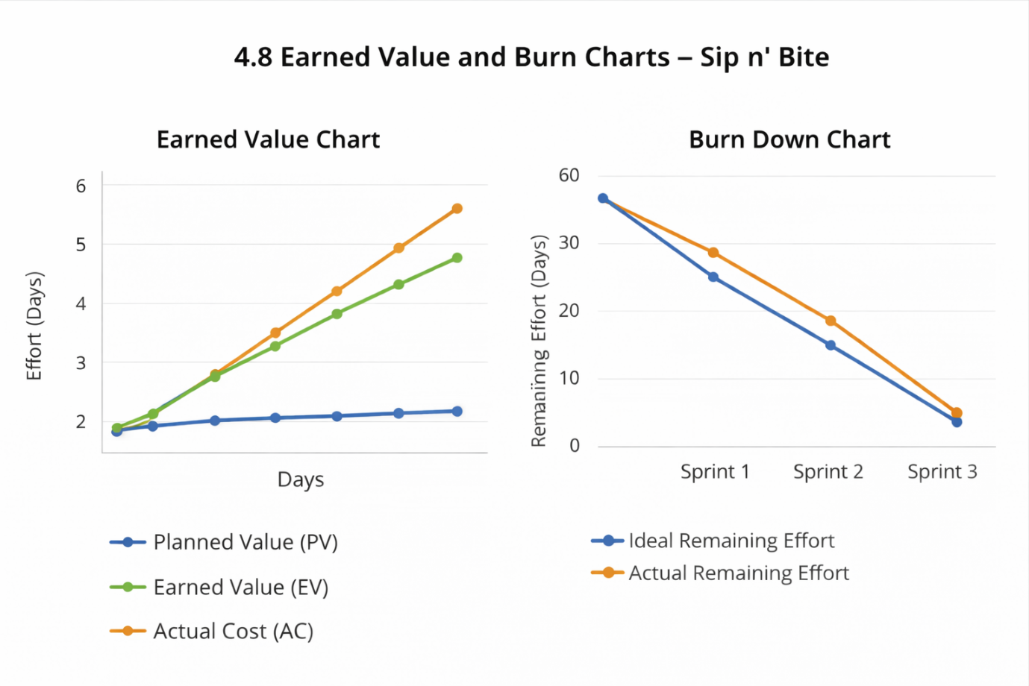

5. Screenshots:
- Admin Dashboard:
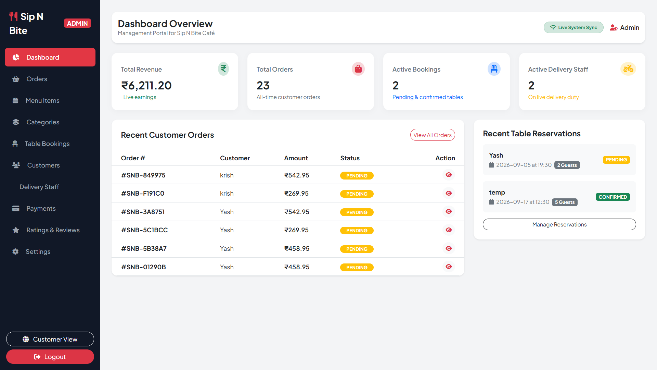

Admin’s dashboard overview.

- Admin Order Management:

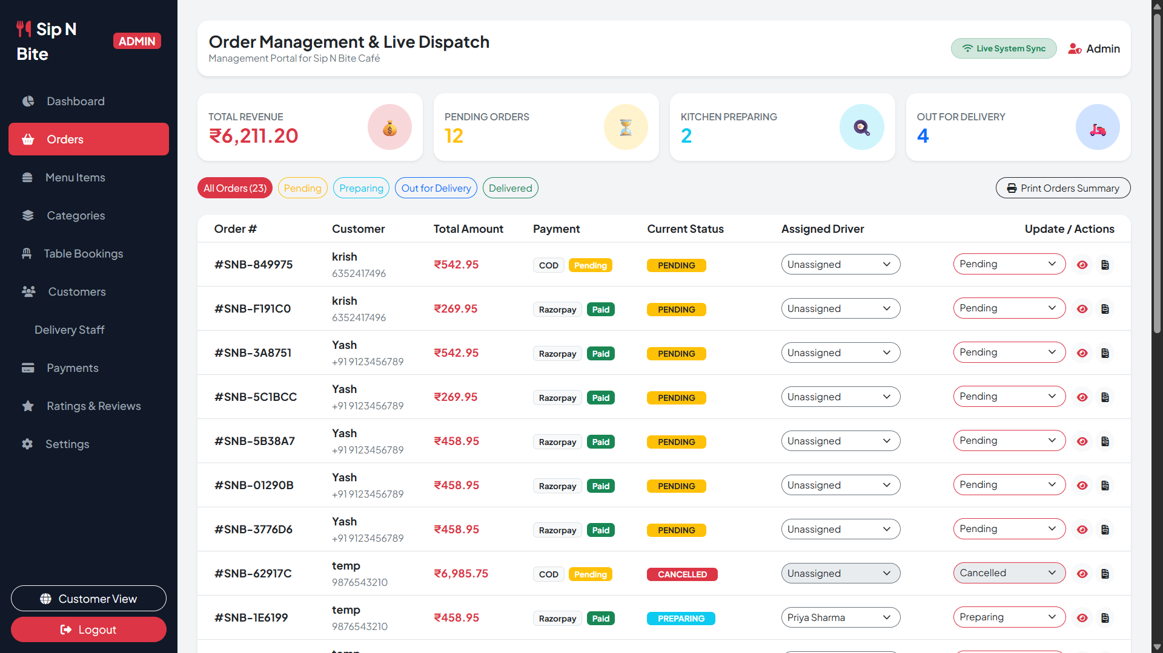

Admin can manage order from here.

- Admin Menu Management:

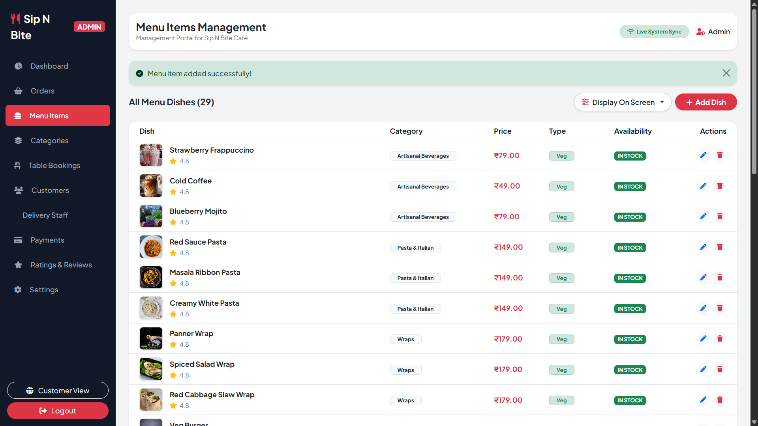

Admin manage menu of the café from here.

- Admin Table Management:

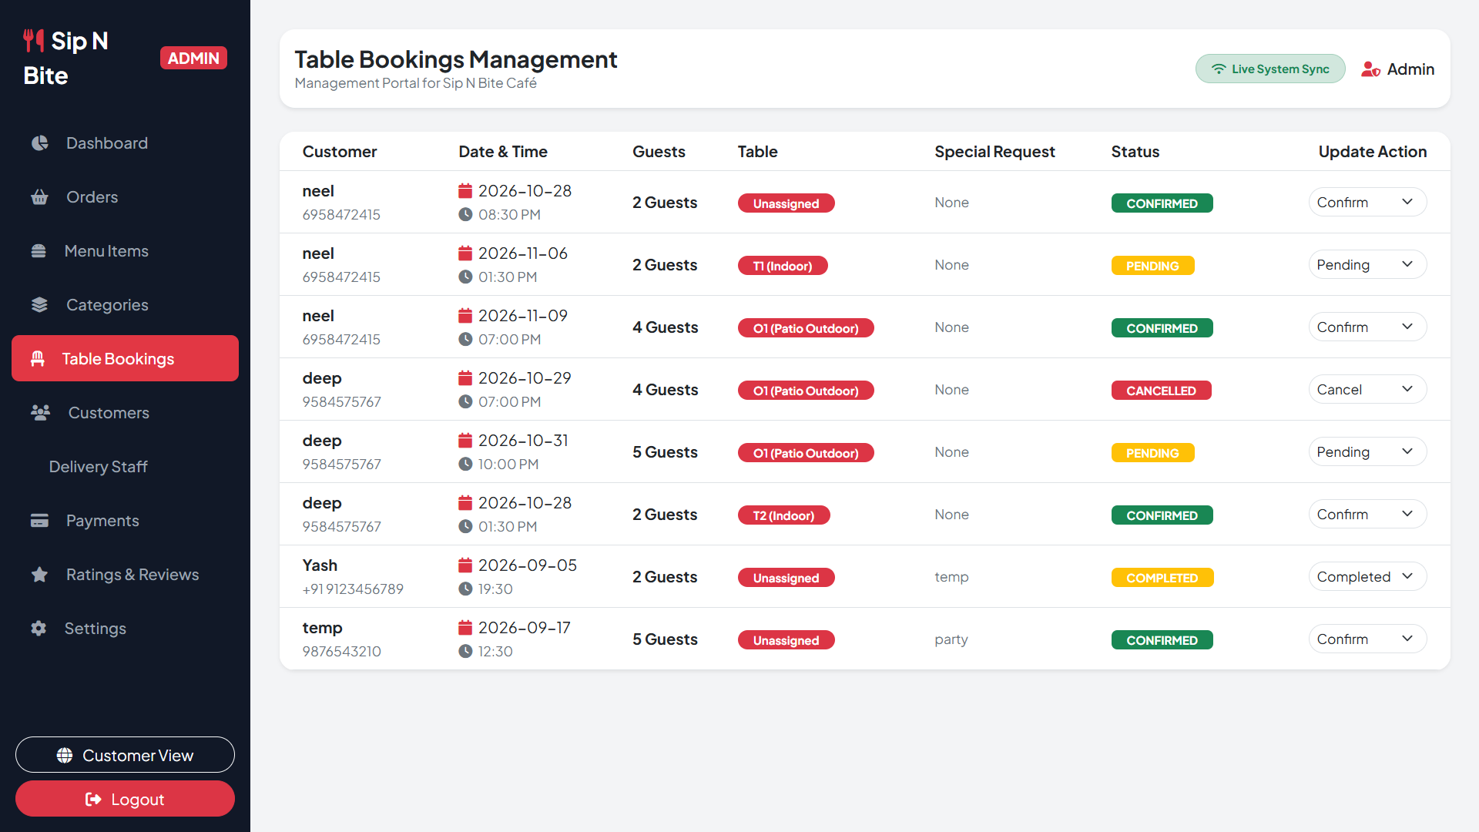

Admin can perform table allotment from here.
- Admin Customer Management:
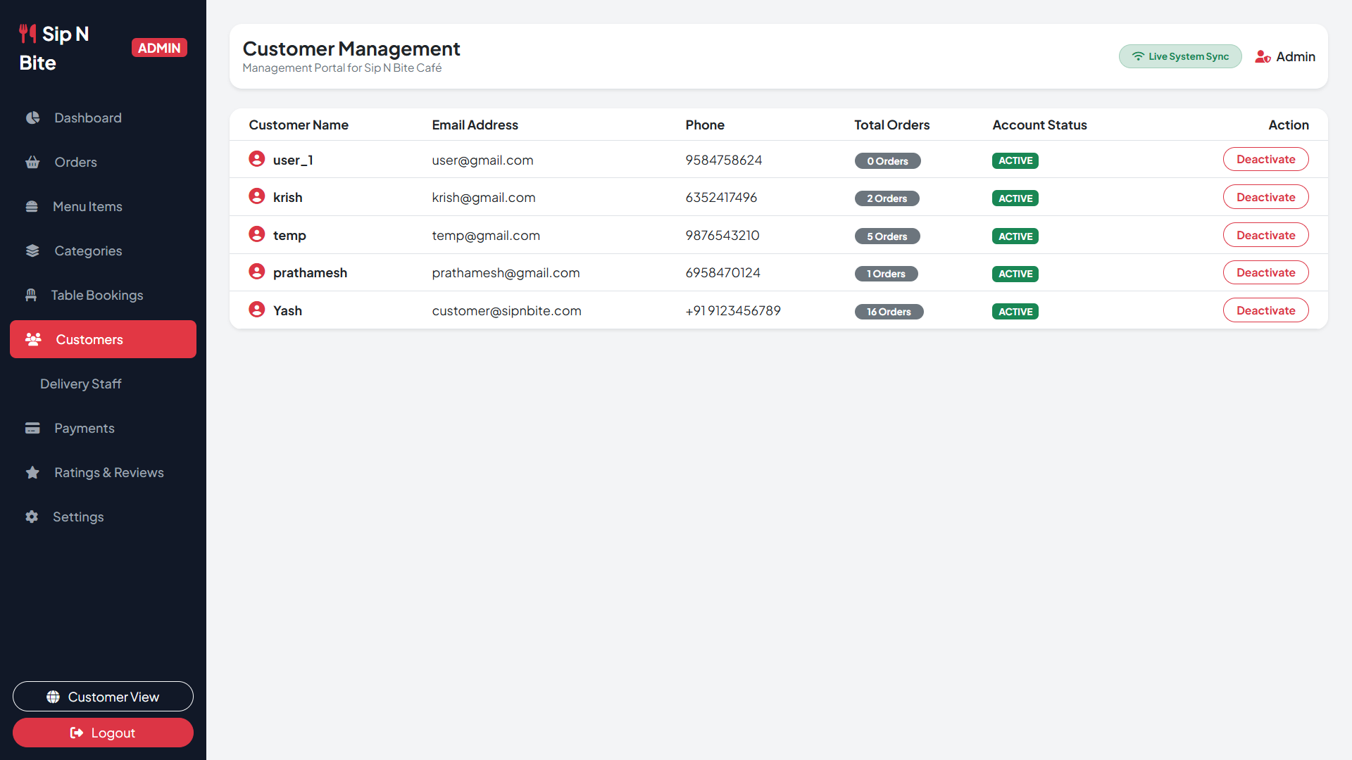
Admin view the list of customer from here.

- Admin Delivery Partners Management:
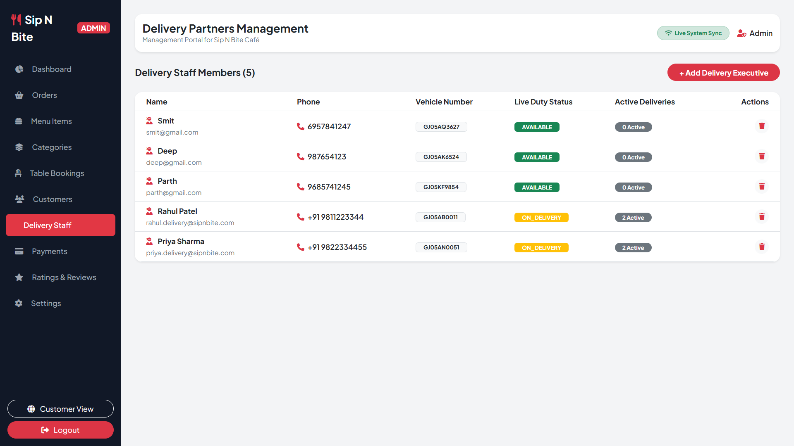
Admin manage delivery partners from here.

- Admin Payment Tracker:
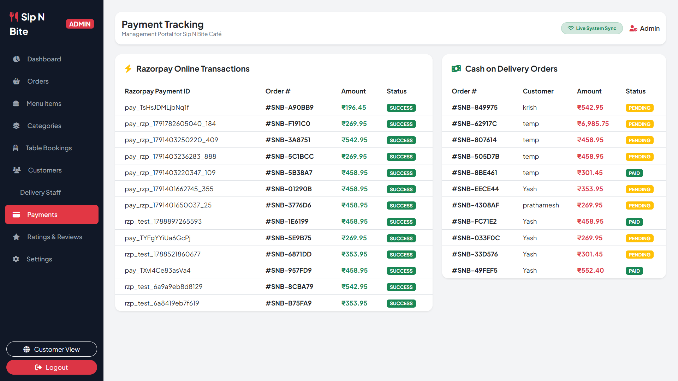
List of payment displayed here.

- Customer Rating & Review:
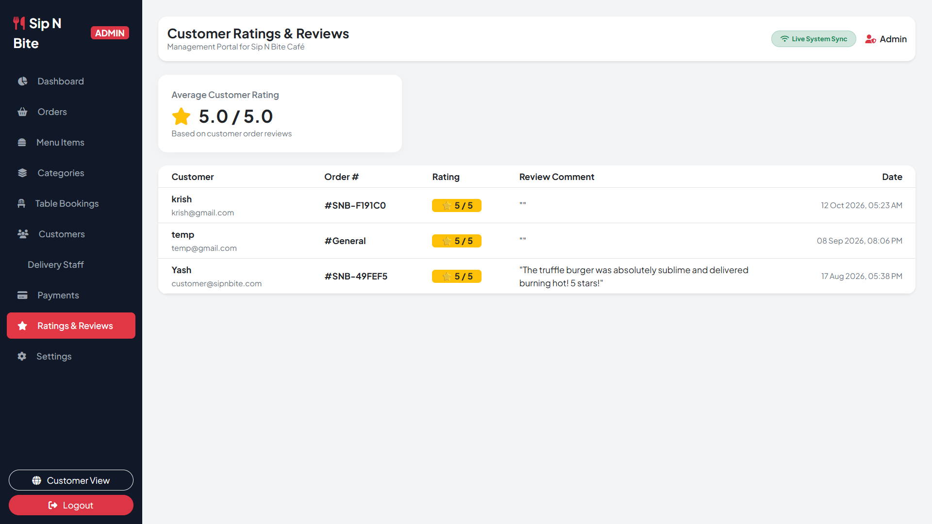
Reviews and rating displayed here.

- Web:
- Customer Registration:
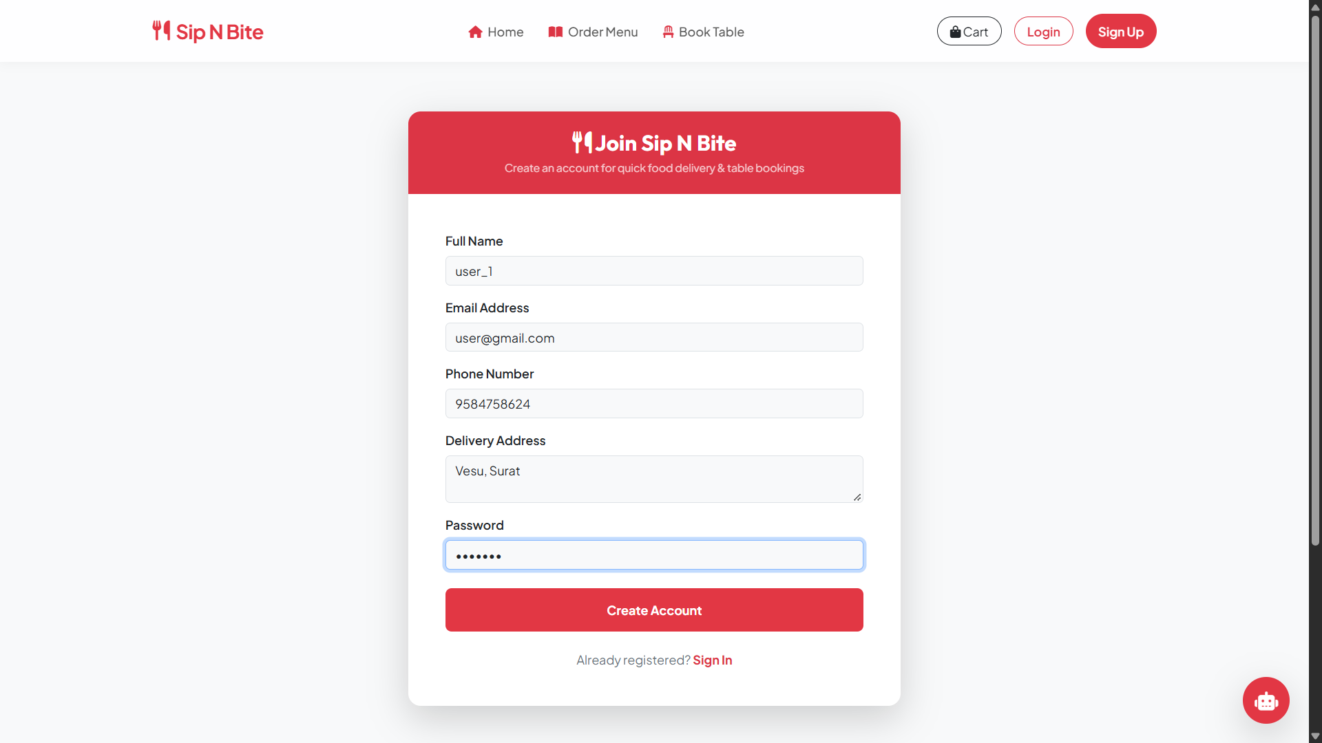

Customer register themselves from here.

- Customer Login:

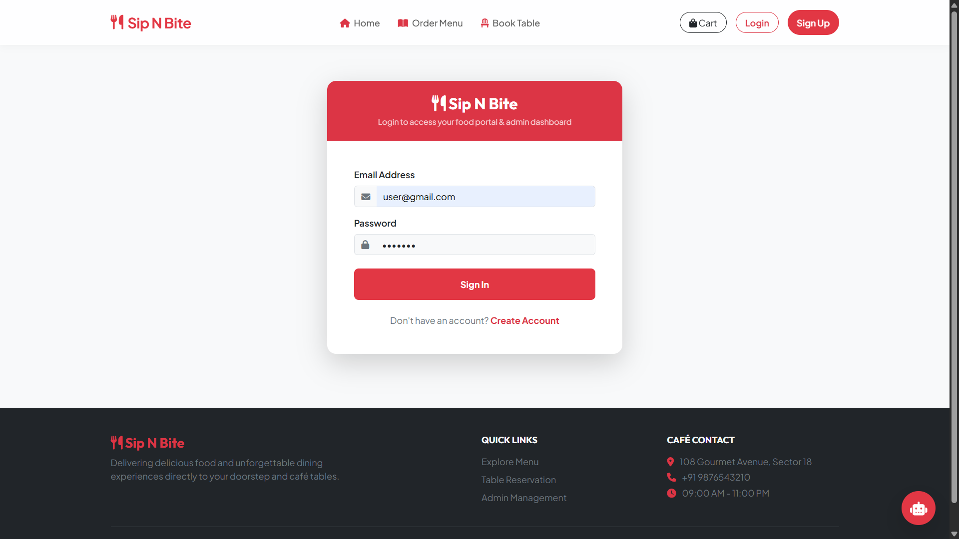

Customer login from here if they have account.

- Customer Side Home Page:

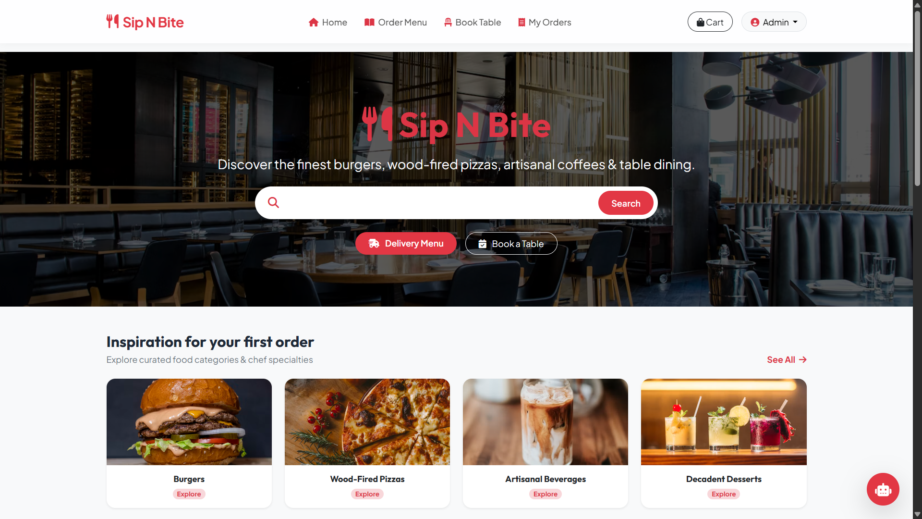

Introduction page of the café.

- Customer Side Menu:

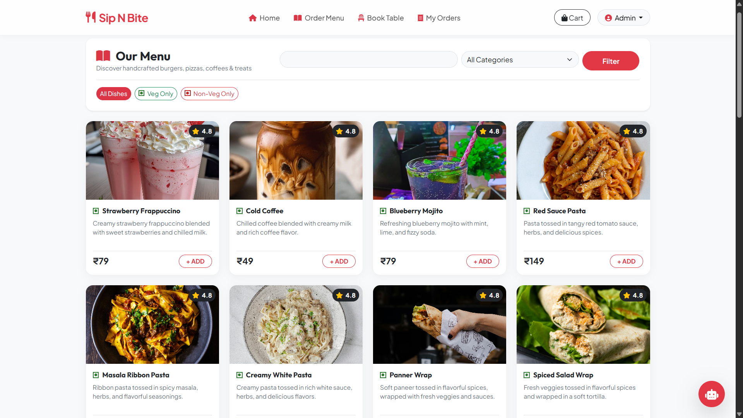

Available Dishes of the customer.

- Customer’s Table Booking:

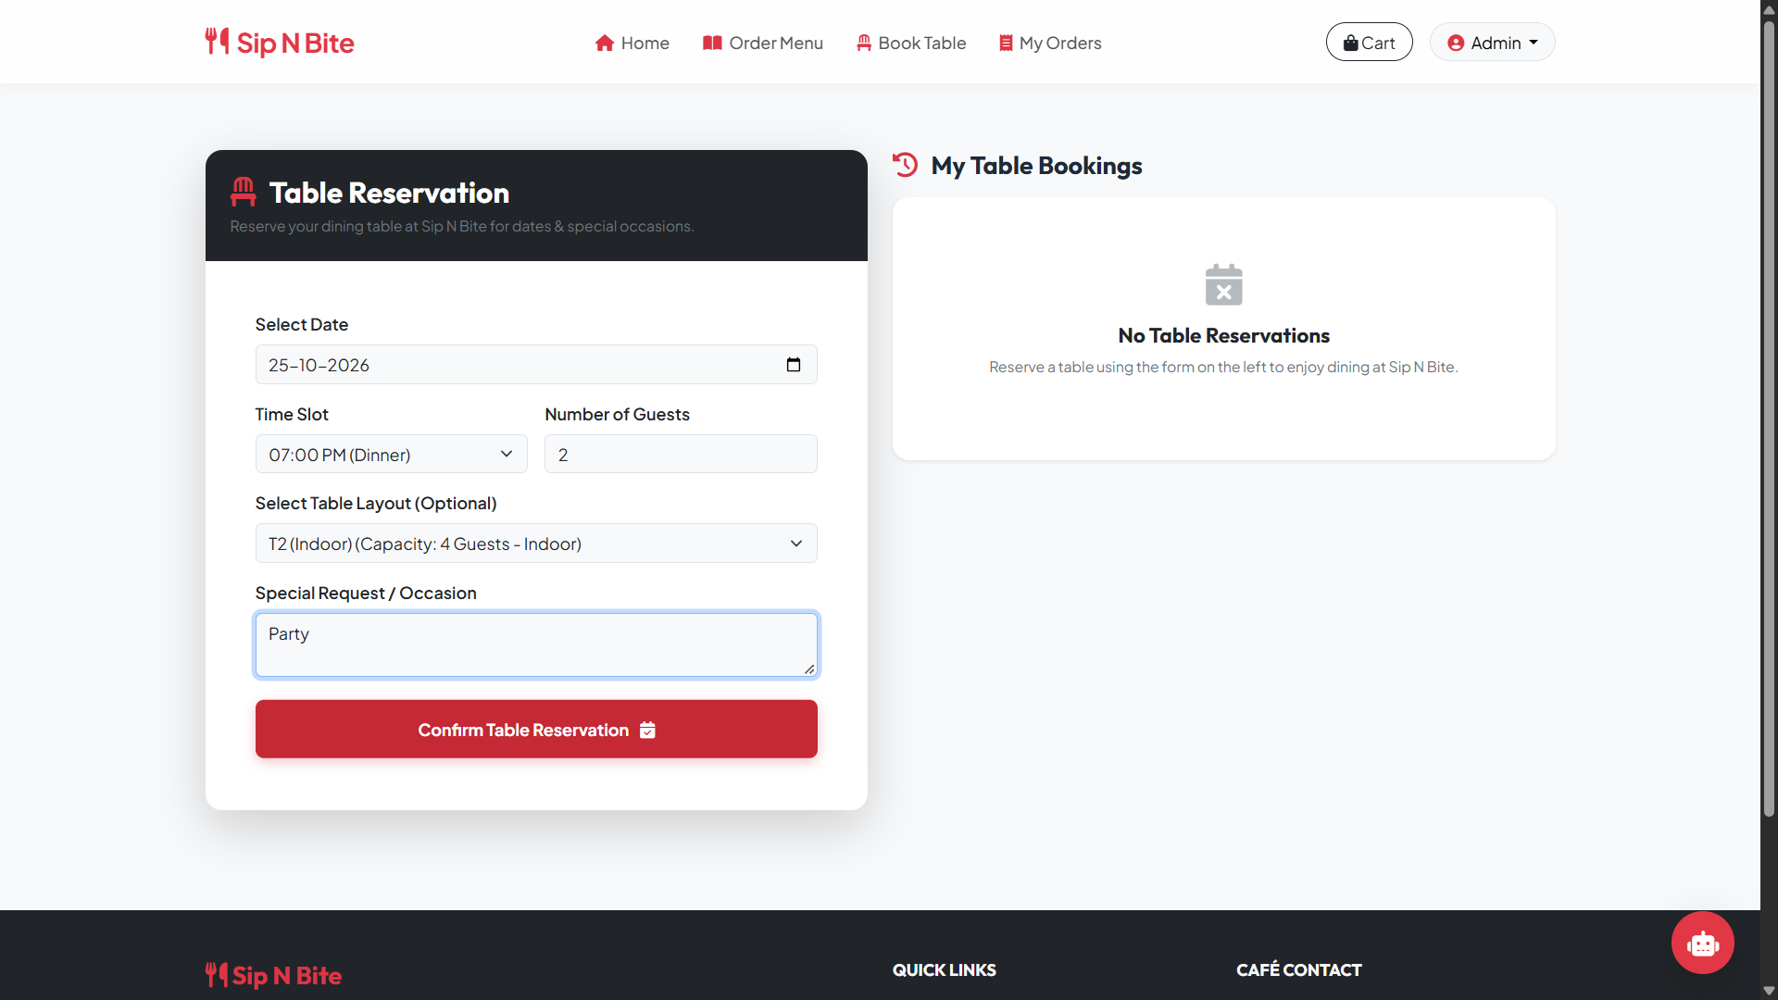

Customer book page according their need.

- Customer’s Cart:

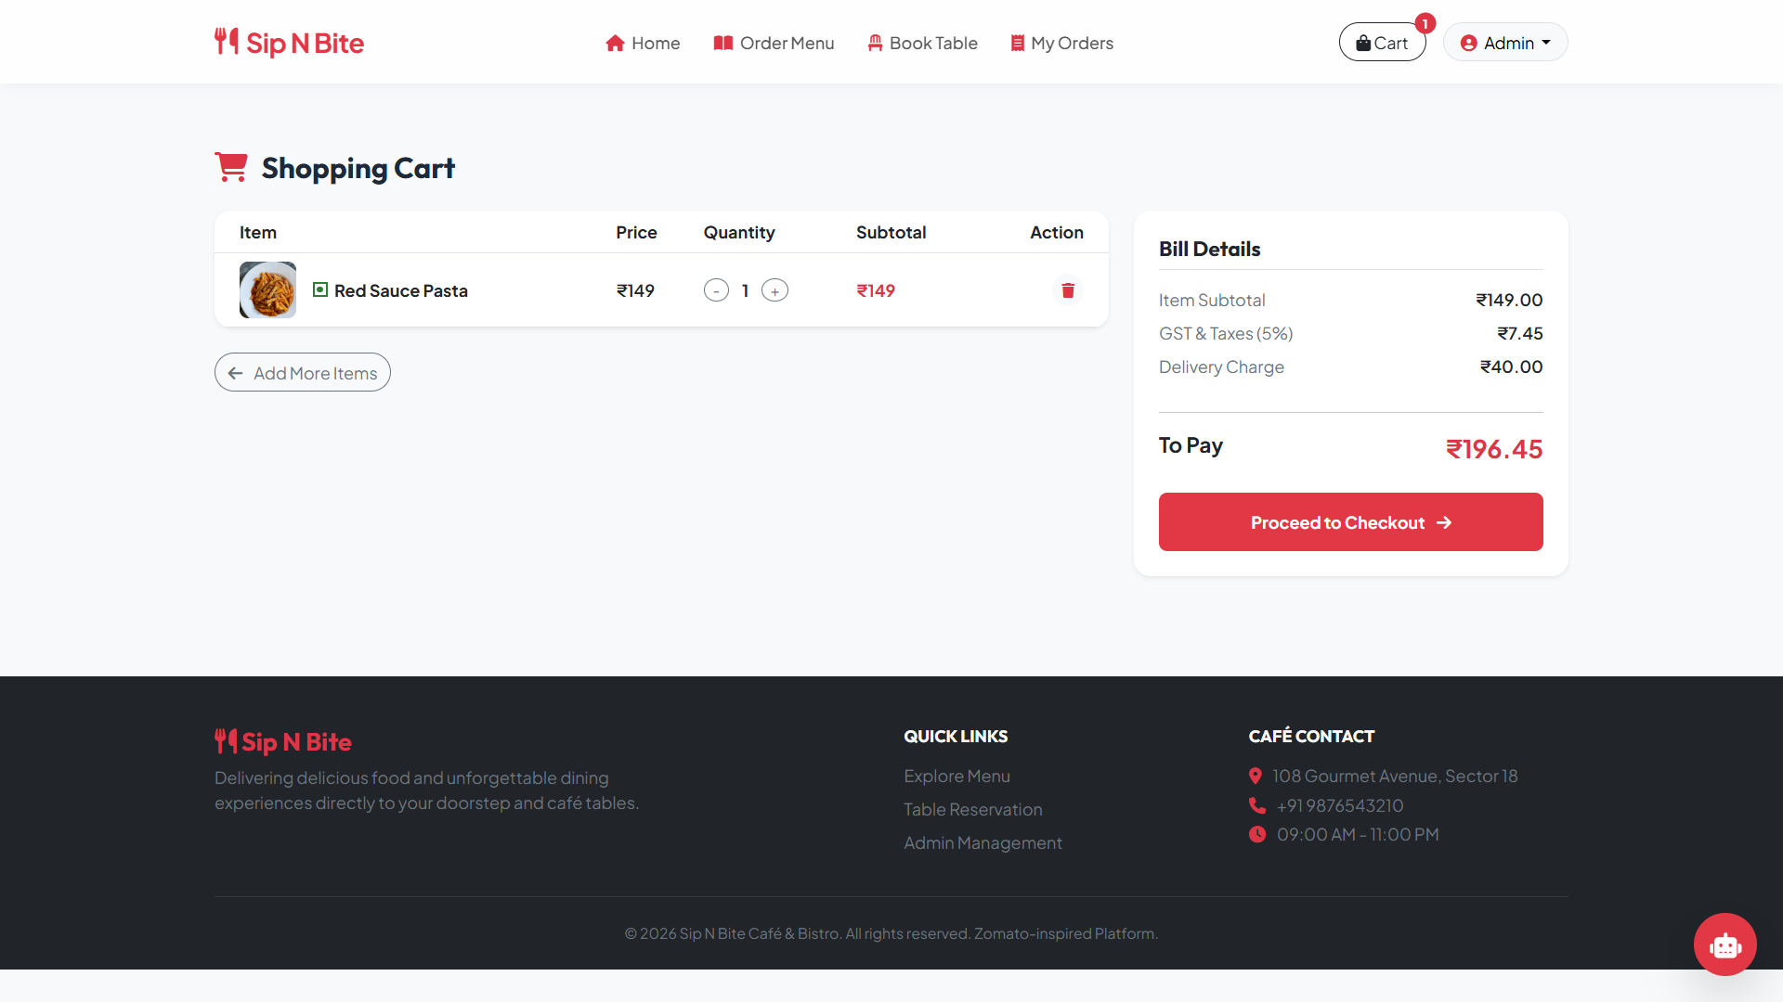

Selected food displayed here with the final price including tax and chargers.

- Customer’s Checkout Page:

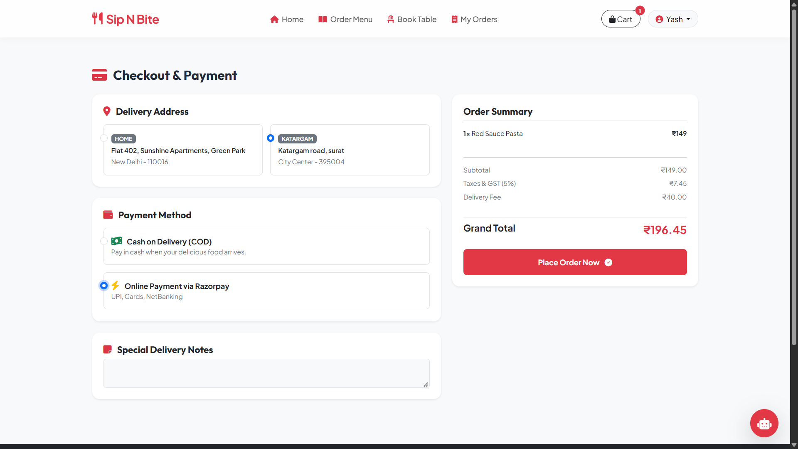
Check out page where customer has to select delivery address and payment option.
- Customer’s Online Payment:

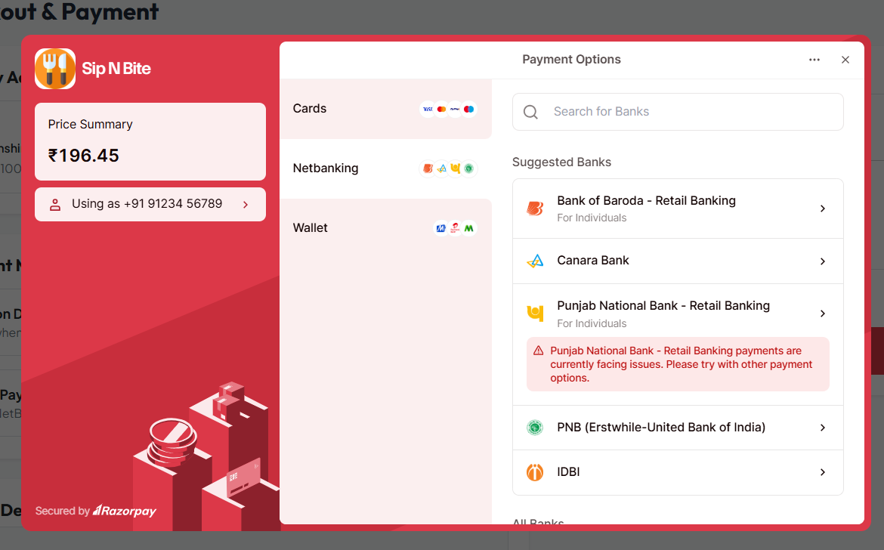

Screen appear if customer pay online.
- Customer’s Order Placed:

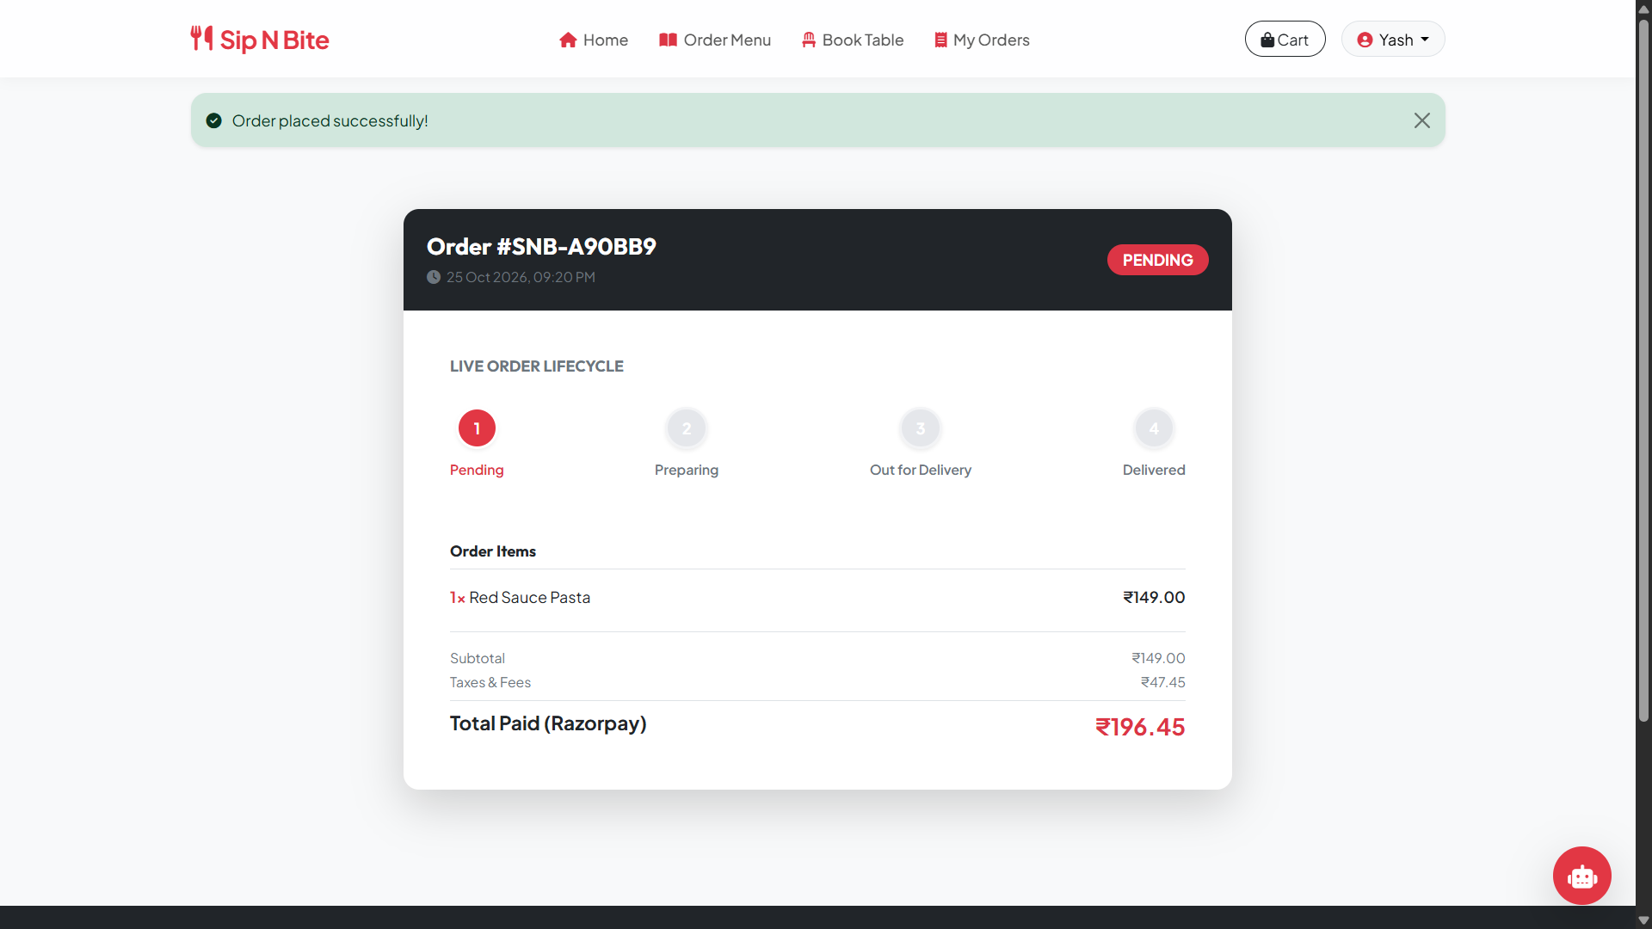

Tracking/Status screen of the placed order.

- Customer’s order History:

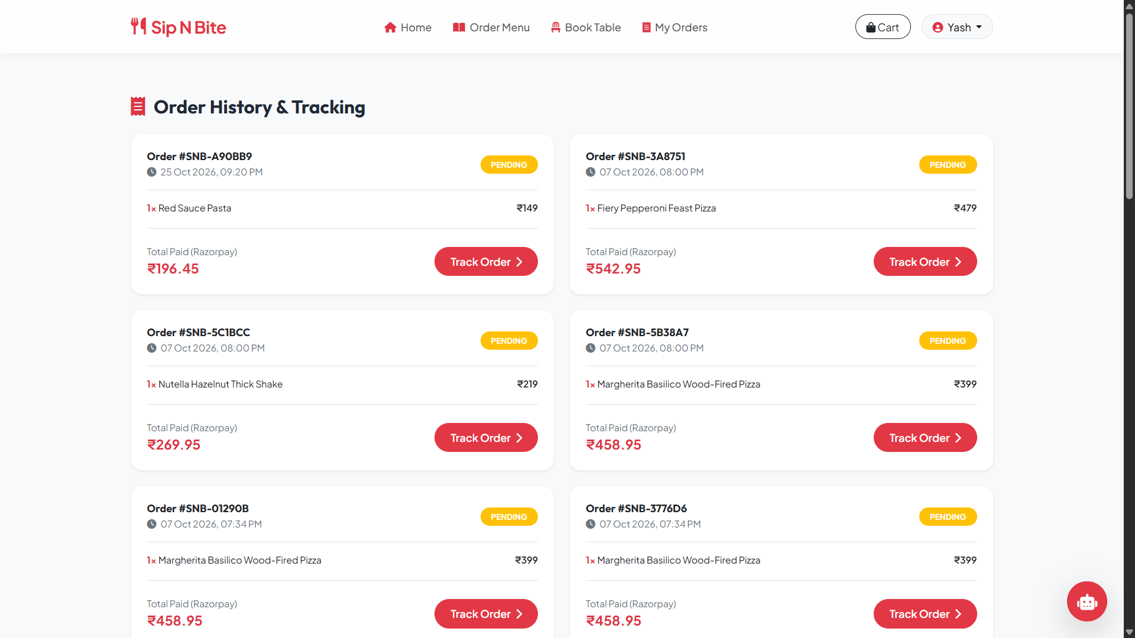

Customer’s all order or history on this page.

- Customer’s Profile:

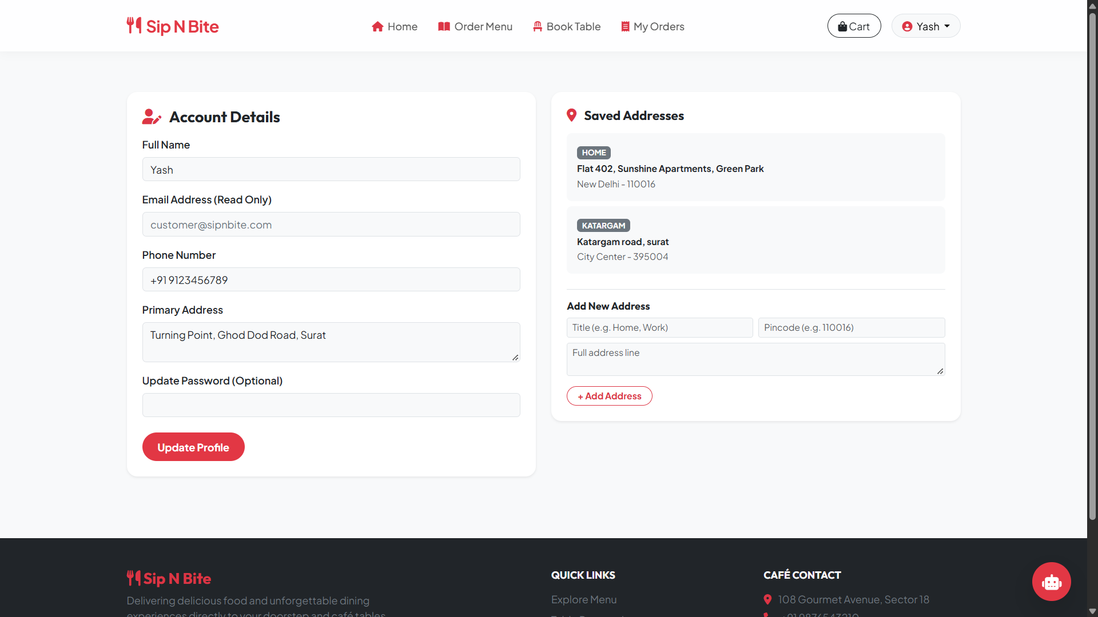

Customer Profile where all the details displayed.

- AI ChatBot:

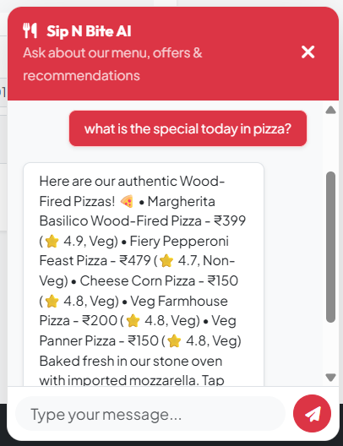

AI helps customer to place order with best offer and food.
- Android:

- Customer Home Page:

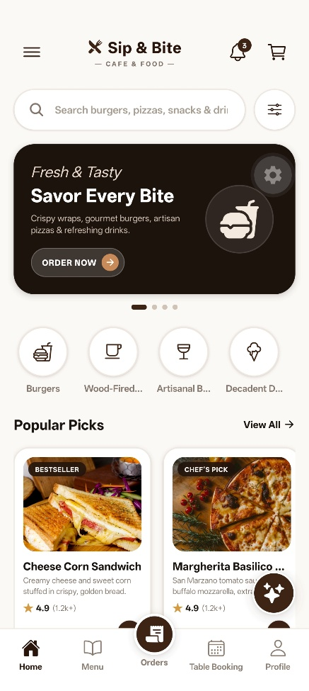

6. CONCLUSION

The Sip N’ Bite system has been successfully designed and developed to provide an efficient and user-friendly platform for managing café services. The system simplifies the overall process of table booking, order management, and delivery handling by integrating the functionalities of customers, admin, and delivery partners into a single platform.

Through this project, users can easily browse services, place orders, make payments, and track their activities, while the admin can efficiently manage operations and maintain system records. The inclusion of delivery partner functionality further enhances the system by ensuring timely and organized order delivery.

This project has not only improved our understanding of software development concepts but also provided practical experience in designing real-world applications. It demonstrates how technology can be used to enhance convenience, reduce manual effort, and improve service quality.
In conclusion, the system fulfills its intended objectives and provides a strong foundation for future enhancements, making it a scalable and effective solution for modern café management.

